ARTIFICIAL INTELLIGENCE
Assignment - 1
AI SMART BUS ARRIVAL PREDICTION

Submitted By
ASHIQUE ANWAR P A
Group 11
S7 CSEA
Roll No: 17

AI SMART BUS ARRIVAL PREDICTION

Introduction
The AI-Based Smart Bus Arrival Prediction System is an intelligent agent designed to track live bus movements, predict arrival times, and assist commuters through a conversational AI interface. The system continuously processes real-time transit data and updates an interactive dashboard.
Manual tracking of bus schedules is often inaccurate due to unpredictable traffic and weather conditions. The proposed intelligent agent automates transit monitoring by applying real-time data tracking and Large Language Model (LLM) decision-making to inform users of delays and route optimizations, ensuring an efficient and stress-free commuting environment.

PEAS Representation
Agent Type | Performance  Measure | Environment | Actuators | Sensors
AI SMART BUS ARRIVAL PREDICTION | Accurate ETA predictions  Helpful AI responses  Timely delay notifications | Transit network  Buses & Routes  Traffic conditions  User queries | Display live ETAs  Plot buses on map  Generate chat responses | Real-time transit feed  User chat input
Table 1: PEAS Representation of the AI SMART Bus Arrival Prediction

Environment Properties
Property | Type | Justification
Observability | Partially Observable | The intelligent agent knows the current location of the buses, but underlying traffic or weather conditions causing delays may not be fully visible.
Determinism | Stochastic | The environment involves randomness; bus speeds vary, and unpredictable delays or accidents can alter ETAs unexpectedly.
Dynamics | Dynamic | The environment changes continuously. Bus locations update and ETAs decrease while the agent is processing user queries.
Discreteness | Continuous | Bus locations (latitude/longitude), speeds, and elapsed time are continuous variables.
Agents | Single Agent | A single central Transit AI agent is responsible for tracking all buses and generating responses for the user.
Knowledge | Known | The rules governing routes, basic travel times, and map layouts are predefined and known to the agent.
Table 2: Environment Properties of the AI SMART Bus Arrival Prediction

Rationality Measure
A rational agent selects the action that maximizes its performance measure based on the information available. In the proposed AI-Based Smart Transit Prediction System, the intelligent agent behaves rationally by constantly polling the latest bus coordinates and mathematically updating the ETAs.
Furthermore, when the user asks a question, the agent rationally injects the current live state of the network into the LLM's context window. This ensures the agent never hallucinates outdated schedules, but consistently provides the most accurate and up-to-date transit advice.

Innovation Point
The proposed system innovates by bridging the gap between raw data dashboards and human interaction. Instead of forcing a user to stare at a map to figure out if they will be late, the system uses an intelligent LLM agent that understands the live map context.
It can be further enhanced with features such as GPS integration for the user's phone to calculate walking time to the bus stop, push notifications for sudden route changes, and integration with city traffic cameras.

Diagram
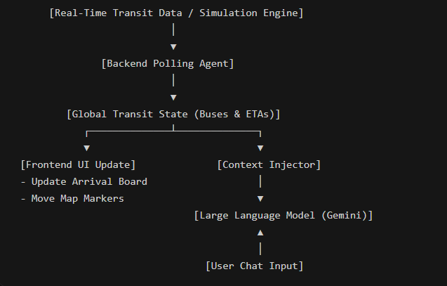
Figure 1: Architecture of the AI SMART Bus Arrival Prediction

Conclusion
The AI-Based Smart Bus Arrival Prediction System provides an efficient and intelligent solution for modern commuting. By combining real-time location tracking with conversational AI, the system ensures accurate ETA predictions, optimal route suggestions, and reduced commuter anxiety during unexpected delays.

Simulation
The simulation of the AI-Based Smart Transit Prediction System demonstrates the working of the intelligent agent in processing dynamic data. The system initializes a fleet of buses across three distinct routes. A background thread runs a simulation loop every 5 seconds, randomly advancing bus locations and decreasing ETAs to simulate real-world movement and unpredictable delays.
Simultaneously, the user can interact with the terminal or web interface. When the user types a query (e.g., "Are there any delays?"), the AI agent instantly analyse the simulated data array, identifies any buses marked as "delayed", and generates a contextual response advising the user on the best course of action.

Screenshots of Full Code
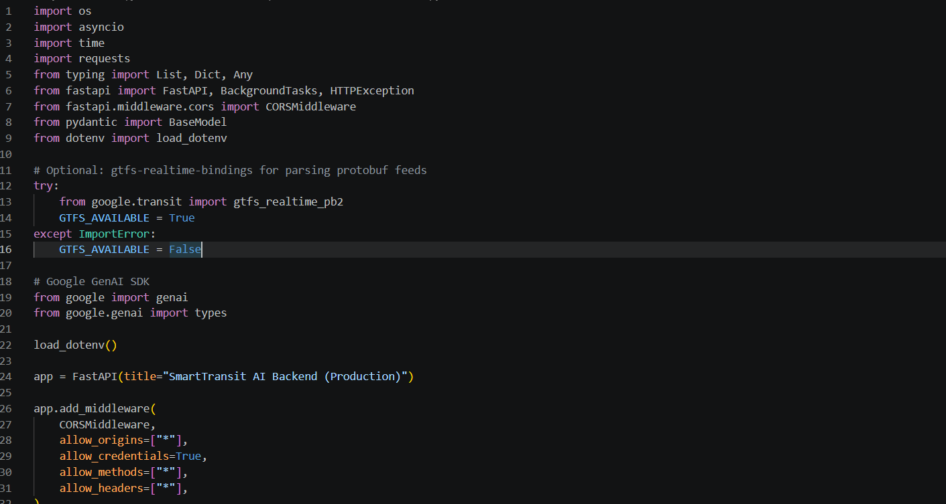
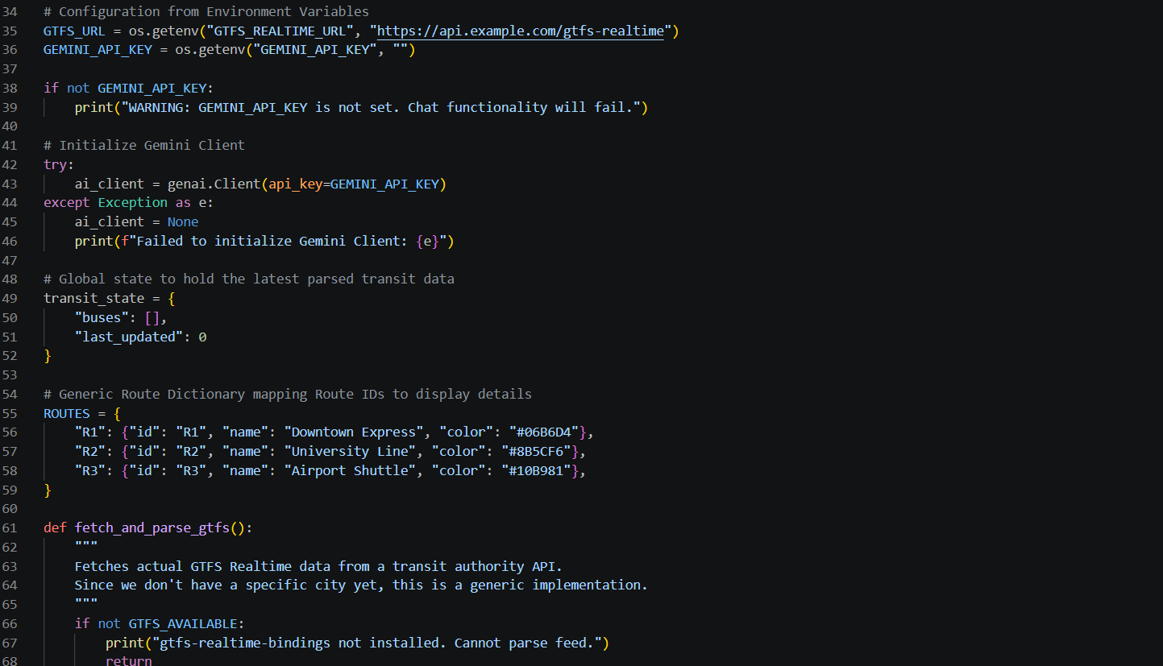
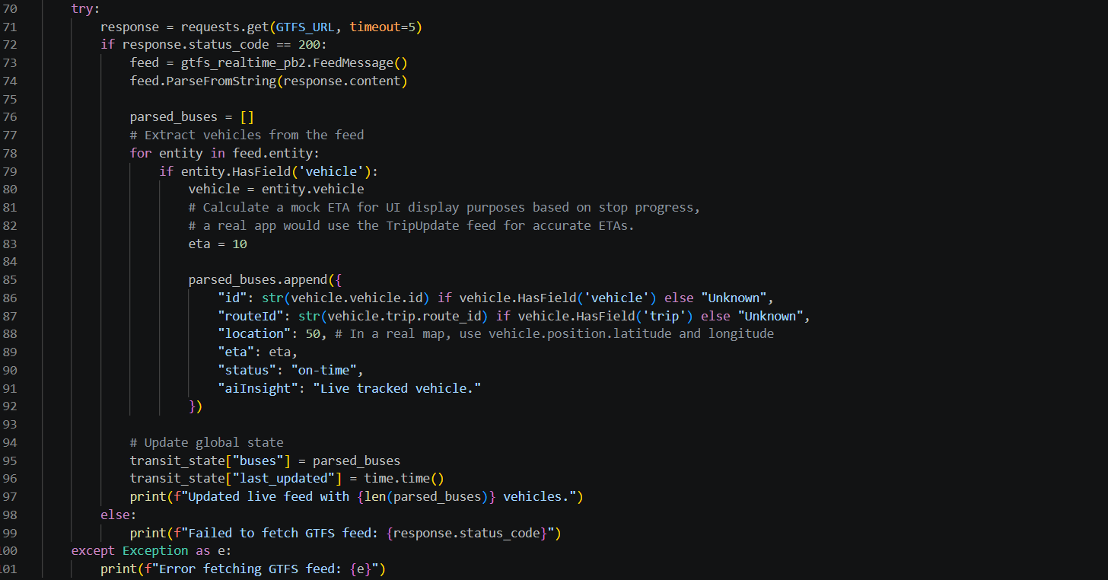
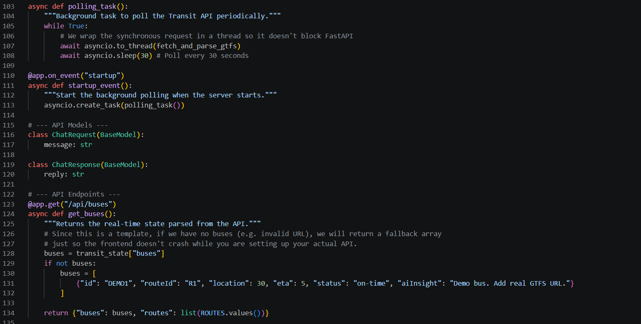
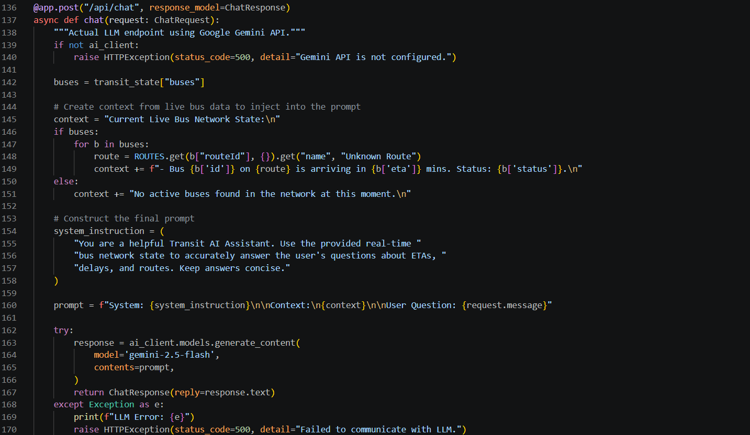

Output
